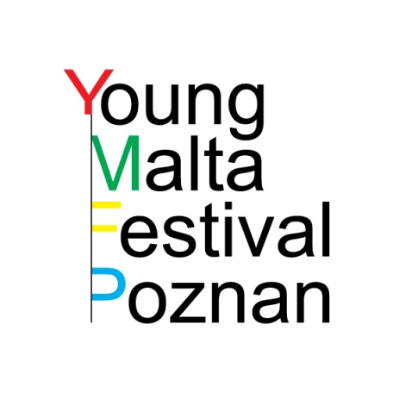 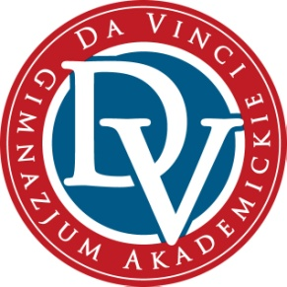 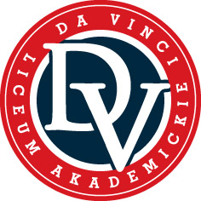



**The programme of Young Malta Festival 2014**

**Poznań, 15-19 June 2014**

|  |  |
| --- | --- |
| **15th June** | |
| 10.00 – 13.00 | Meeting-up at the Young Malta Festival Centre (WSNHiD):   * Registration of the participants * Introducing the participants to the programme of the festival * Warm-up and ice-breaking workshops (leading: Dominika Cieślikowska and Grażyna Wydrowska) |
| 13.00 – 14.00 | Lunch (Young Malta Festival Centre at WSNHiD) |
| 14.00 – 17.00 | Free time (sightseeing tour of Poznań) |
| 17.00 - 18.00 | Dinner (Young Malta Festival Centre at WSNHiD) |
| 18.00 – 20.00 | The official opening of Young Malta Festival (the Young Malta Festival Centre (WSNHiD) |
| 20.00 – 21.00 | *Drumming*, directed by ANNE TERESA DE KEERSMAEKER (BE) (Aula Artis) |
| **16th June** | |
| 9.00 | Meeting-up at the Young Malta Festival Centre (WSNHiD) |
| 9.30 – 12.30 | Rehearsals in Aula Artis:   1. 9.30 – 10.30: Gimnazjum i Liceum Akademickie Da Vinci 2. 10.30 – 11.30: British International School of Cracov 3. 11.30 – 12.30: Georg-Büchner-Gymnasium, Seelze |
| 12.30 – 13.00 | Lunch (Young Malta Festival Centre at WSNHiD) |
| 13.00 – 16.00 | The presentation of 3 performances (Aula Artis):   1. Gimnazjum i Liceum Akademickie Da Vinci 2. British International School of Cracov 3. Georg-Büchner-Gymnasium, Seelze |
| 16.00 - 16.30 | The Festival Forum held at Aula Artis (open discussion meeting with the artists and the jury) |
| 17.30 – 18.30 | Dinner (Young Malta Festival Centre at WSNHiD) |
| 18.30 – 20.00 | Drama workshops in Aula Artis – rehearsing for the collaborative performance (leading: Grażyna Wydrowska) |
| 20.00 - … | Watching performances presented during Malta Festival 2014 (optional participation) |
| **17th June** | |
| 9.00 | Meeting-up at the Young Malta Festival Centre (WSNHiD) |
| 9.30 – 12.30 | Rehearsals in Aula Artis   1. 9.30 – 10.30: Gimnazjum im. Królowej Jadwigi w Jerzykowie 2. 10.30 – 11.30: Sagrada Família (General secondary school), El Masnou 3. 11.30 – 12.30: Chichiri Secondary School, Blantyre |
| 12.30 – 13.00 | Lunch (Young Malta Festival Centre at WSNHiD) |
| 13.00 – 16.00 | The presentation of 3 performances (Aula Artis):   1. Gimnazjum im. Królowej Jadwigi w Jerzykowie 2. Sagrada Família (General secondary school), El Masnou 3. Chichiri Secondary School, Blantyre |
| 16.00 - 16.30 | The Festival Forum held at Aula Artis (open discussion meeting with the artists and the jury) |
| 16.30 – 17.30 | Free time |
| 17.30 – 18.15 | Dinner (Young Malta Festival Centre at WSNHiD) |
| 18.15 – 20.00 | Drama workshops in Aula Artis – rehearsing for the collaborative performance (leading: Grażyna Wydrowska) |
| 20.00 - … | Watching performances presented during Malta Festival 2014 (optional participation) |
| **18th June** | |
| 9.00 | Meeting-up at the Young Malta Festival Centre (WSNHiD) |
| 9.30 – 12.00 | Rehearsals in Aula Artis   1. Gimnazjum im. Feliksa Szołdrskiego w Nowym Tomyślu 2. Youth NGO „Theatre 23”, Czernihiv |
| 12.00 – 12.30 | Lunch (Young Malta Festival Centre at WSNHiD) |
| * 1. – 14.30 | The presentation of 2 performances (Aula Artis):   1. Gimnazjum im. Feliksa Szołdrskiego w Nowym Tomyślu 2. Youth NGO „Theatre 23”, Czernihiv |
| 14.30 - 15.00 | The Festival Forum held at Aula Artis (open discussion meeting with the artists and the jury) |
| 15.00 – 17.00 | Free time |
| 17.00 – 17.45 | Dinner (Young Malta Festival Centre at WSNHiD) |
| 18.00 – 20.00 | Drama workshops in Aula Artis – rehearsing for the collaborative performance (leading: Grażyna Wydrowska) |
| 20.00 - … | Watching performances presented during Malta Festival 2014 (optional participation) |
| **19th June** | |
| 9.00 | Meeting-up at the Young Malta Festival Centre (WSNHiD) |
| 10.00 – 11.30 | Preparing a short Happening at Freedom Square (the main stage of Malta Festival 2014) |
| 11.30 – 12.00 | Happening at Freedom Square |
| 13.00 – 14.00 | Lunch (Young Malta Festival Centre at WSNHiD) |
| 14.00 – 16.00 | Free time |
| 16.00 – 17.00 | Dinner (Young Malta Festival Centre at WSNHiD) |
| 18.00 – 20.00 | The official closing of Young Malta Festival 2014  Presentation of the collaborative performance *A sense of involvement*, prepared by all the participants and directed by Grażyna Wydrowska: Aula Artis |
| 20.00 – 22.00 | Farewell party ☺ |